Prophetic Prayer Warriors Hit the Streets of England With Miraculous Results

4:00PM EDT 5/17/2016 Steve Strang Charismamag.com

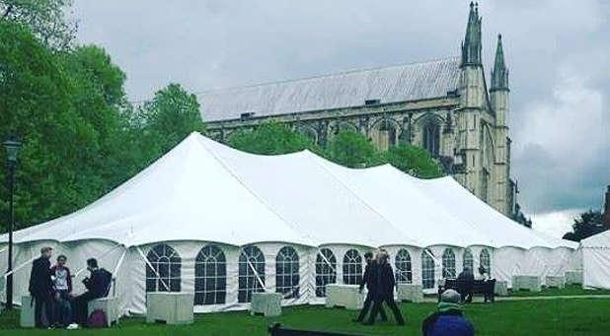

Tent on the Green in Winchester (Facebook)

As I've reported before, I was in England last week and was able to take part in a wonderful three-day event attended by thousands called "Tent on the Green" in front of the historic Winchester Cathedral in Winchester, an hour or so outside London. It was a first of its kind of cooperation between Anglicans and charismatics. I saw dozens raise their hands for salvation. I experienced the power and presence of worship!

I had gone to participate while visiting friends, the Halfords, who pastor in Portsmouth and brought their entire church. In years past, I've been blessed when I've attended Christian events in the U.K., and this sounded fun. What I saw amazed me, and the journalist in me came out. I tracked down Steve Abley—the leader who had a dream last January that resulted in this event—and interviewed him for a podcast. This report came from that interview.

Like most of Europe, England is very secularized and largely hostile to the gospel. But in Winchester, I saw cooperation between different Christian groups. I saw spiritual hunger and sensed a purity of spirit on the part of the leaders who put it on. I saw it as a good sign of hope for spiritual awakening in the country that gave us Charles Wesley, the King James Version of the Bible, Charles Spurgeon and even the Welsh revival in nearby Wales.

To Abley's knowledge, a Christian festival of worship, evangelism, healing and the prophetic had never taken place in the heart of an English city like Winchester.

That's why Abley, Winchester director for Burn 24/7—a prophetic worshipping community that works to engage people of all faiths and backgrounds and introduce them to God—wasn't about to downplay a prophetic dream he had in January to put a Christian festival on at the Outer Close of Winchester Cathedral.

"The Lord spoke to me in this dream and said to put this event together, Tent on the Green," Abley said. "He said, 'Call Me to meet you, and I will meet you all there.' Considering the time constraints, I'd have to say what has taken place has been pretty miraculous. But we have an amazing team."

Abley estimates nearly 8,000 people attended the three-day event this past weekend, plus thousands of others who curiously walked past. He estimated from that crowd, between 180 and 200 people made a commitment to Christ during the festival.

Initially, Abley had hoped to put the festival together to celebrate Easter in 2017. Winchester Cathedral denied the request, but told Abley he and his team could hold the event instead on Pentecost Sunday weekend in 2016—this past weekend. That gave his team less than four months to organize the festival.

On Friday, Abley noticed hesitancy among passers-by to engage with festival workers, not knowing what to expect. But eventually curiosity—and perhaps the Holy Spirit—got the better of their fears.

"On the first day, the stigma of what people thought was Christianity was evident," Abley said. "People looked around, and I could tell they weren't really sure what was going on. They didn't know whether we were going to welcome them in or bash them on the head with a Bible and tell them that they are being judged.

"Of course, none of that last bit is the case. We love people for their sake and not ours. Throughout the weekend, I started to notice people's reactions as if they were to ask, 'This is the church? It's cool, and it's not hard.' If these people went away feeling loved, then fantastic. If they went away with a sense that the church isn't out to kill them and to tell them how wrong they are, and it takes away that stigma that someone else has put onto them, then fantastic. We didn't do that. The Holy Spirit did that. God doesn't need our help."

Those who made a commitment to Christ were also introduced to Burn 24/7's Buddies' program, a six-week discipleship course that helps new Christ followers "focus on their new identity" and eventually train them to connect with others.

Tim Dakin, the Bishop of Winchester Cathedral, preached a gospel message during the weekend and encouraged the crowd to connect with God and others. Dakin spoke of his personal experiences with healing through prayer as well as the rich heritage of London and the United Kingdom.

"We prayed for our city and our nation, and to reclaim our heritage and move forward," Abley said.

Steve Lee, founder of Miracle Street ministry, also preached to the gathering crowds and asked for a response. He had a very effective illustrated sermon with three methods of execution—a guillotine, a hangman's noose and a cross—and told stories of the men who died on them and what resulted. At the end, I saw dozens of people raise their hands when he gave a call for salvation. I wondered how long it had been at Winchester Cathedral since that many people had given their lives to Christ.

On Sunday evening, Winchester Cathedral hosted a national prayer-and-worship event called "Thy Kingdom Come." Sunday evening, Christian singer and songwriter Matt Redman led the worship service. Through live links to other cathedrals around England, Archbishop of Canterbury Justin Welby prayed for and addressed the nation.

I had to return to London to prepare for my long trip home, so I missed the evening service. I would have loved to stay. I came home encouraged by what I heard and saw, and I hope you are too.

If you subscribe to my Strang Report podcast, later in the week you will be able to hear my entire interview with Steve Abley.